**P.5 MATHEMATICS LESSON NOTES TERM ONE**

**SET CONCEPT**

**A set.**

A set is a collection of well-defined elements or members

Review on the following

- Equal sets

- Un equal sets

- Equivalent sets

- Non equivalent sets

**INTERSECTION SETS (Ո)**

A set of common elements found in two or more sets.

The symbol for intersection is **Ո**

**Example I**

Given set A = {a, b, c, e, f, g}

B = {b, d, e, f, g}

Find A n B

A n B = {b, e, f, g}

**Example II**

Set K = {a, e, i, o, u}

B= {a, b, c, d, e, f, g, h, i}

(i) Find (i) K n B = {a, e, i)

(ii) n(KnB) = 3

**Examples III**

K = {Odd numbers less than 10}

M = {prime numbers less than}

(i) List members of K

K = {1, 3, 5, 7, 9}

M = {2, 3, 5, 7}

(ii) Find AnB = {3, 5, 7}

**Activity**

1. Given set B = {1, 2, 3, 4, 5, 6} and K = {3, 4, 5, 6, 7, 8, 9}

List members of (ii) A n B

Find n(AnB)

2. P = {0, 1, 2, 3, 4, 5}

Q = {0, 2, 4, 6, 8}

Find (i) PnQ

(ii) n(PnQ)

3. Given set m = {vowel letters}

B = {a, b, c, d, e}

Find (i) MnB)

(ii) n(MnB)

4. Set Q = {Even numbers less than 12}

B= {4, 6, 8, 9, 10, 12}

Find (i) QnB

(ii) n(QnB)

5. Set H = {Odd numbers less than 13}

M= {2, 3, 4, 5, 6, 7, 8, 9}

Find (i) HnM

(ii) n(MnH)

**UNION SETS**

A union set is a set with all members of given sets.

**Note:**

Common members of two or more sets are written once.

The symbol for Union **U**

1. Given M = {orange, mangoes, pawpaw}

K = {tomatoes, peas, pineapples}

Find MuK = {oranges, mangoes, pawpaw, tomatoes, peas, pineapples)

2. Set H = {4, 6, 8, 9, 10, 12, 14}

B = {0, 2, 4, 6, 8, 9, 10, 12, 14}

Find HUB = {0, 2, 4, 6, 8, 9, 10, 12, 14}

n(HUB) = 9

3. Set W = {Prime numbers less than 13}

P= {Odd number less than 13}

Find (i) WuP

(ii) n(WUP)

**Soln**

W= {2, 3, 5, 7, 11}

P= {1, 3, 5, 7, 9, 11}

WUP = {1, 2, 3, 5, 7, 9, 11}

n(WUP) = 7

**Activities**

1. Set M= {1, 2, 3, 4, 5, 6, 7}

K = {1, 2, 3, 4, 5, 8, 9, 10}

Find MUK

2. Set H = {composite numbers less than 12}

B= {Prime numbers less than 13}

Find (i) HUB

(ii) n(HUB)

3. Set R = {Even numbers less than 14}

H= {counting numbers less than 12}

Find (i) RUH

(ii) n(RUH)

4. Set M = {Natural numbers less than 10}

B = {1, 3, 5, 7, 9}

Find (i) MUB

(ii) n(MUB)

5. Set R = {1, 4, 9,16, 25, 36}

H = {0, 2, 4, 6, 8, 10, 12}

Find (i) RUH

(ii) n(RUH)

**UNIVERSAL SETS ( )**

A universal set is a set which contains of all elements from which other sets are formed.

The set symbol for universal set is

Example 1

Set M = {1, 2, 3, 4, 5}

Q = {4, 6, 8, 9}

B = {4, 8, 9}

 ( ) = {1, 2, 3 , 4, 5, 6, 7 , 8 , 9}

**DIFFERENCE OF SETS**

Is a set of elements that belong to only one set.

Examples

1. Given set K = {5, 6, 7, 8, 9, 10, 11, 12}

B = {2, 3, 5, 7, 11, 13}

What is (i) K – B? (members of set K only)

**Soln**

K – B = {6, 8, 9, 10, 12}

B – K = {2, 3, 13}

2. Given the E= {Whole numbers less than 10} and

P = {Prime numbers between 1 and 12}

Find (i) P – E

(ii) E – P

**Soln**

E = {0, 1, 2, 3, 4, 5, 6, 7, 8, 9}

P= {2, 3, 5, 7, 11}

1. P – E = {11}

n (P- E) = 1

E – P = {0, 1, 4, 6, 8, 9}

n (E – P) = 6

3. Given that set Q= {0, 2, 6, 8, 9,10}

M = {1, 2, 3, 4, 6, 11, 13}

Find (i) Q – M

(ii) n (Q – M)

1. M – Q
2. n (M – Q)

Soln

1. Q – M = {0, 8, 9, 10}
2. n (Q – M) = 4
3. M – Q = {1, 3, 11, 13}

n (M – Q) = 4

**Activity**

1. T = {a, b, c, d, e}

S = {a, e, i, o, u}

Find

1. T - S
2. S – T

2. Set H = {all even numbers less than 10}

L = {all odd numbers less than 10}

(a) How many elements are in K – L?

(b) List down all members of L – K?

3. Given that M = {d, n, p, r, t, y} and

N = {c, d, k, m, n, x, v}

1. List all the members of M and N

(b) Find (i) M – N

(ii) n (M – N)

(c) (iii) N – M

(iv) n (N – M)

4. Given that E = {whole numbers less than 16}

And A = {Odd numbers less than 16}

(a) List the members of E and members of A

E = { } A = { }

(b) Find (i) A – E

(ii) E - A

**COMPLEMENT OF SETS**

Complement of a set means a set of members that don’t belong to a given set.

It is a set of elements outside the mentioned set.

Given A**I**, this is read as A complement.

**Examples** 1

Given that: P = {4, 3, 6, 7, 9} and

Q = {1, 2, 3, 5, 7}

Write down members of PI (complement of set P)

PI = {1, 2, 5}

n(P1) = 3

**Examples II**

Given M = {0, 4, 6, 8, 9}

H = {1, 2, 4, 6, 10, 12}

Find m1 = {1, 2, 10, 12}

HI = {0, 8, 9}

**Examples III**

Given N = {4, 6, 8, 9, 10, 12}

R = {0, 2, 4, 6, 8, 10}

Find the compliment of set R

**Soln**

R**I** = {9, 12}

(ii) Find N**I** = {0, 2}

**Activity**

1. Given A = {1, 2, 3, 4, 5, 7, 9}

B = {0, 2, 4, 6, 8}

Find (i) A1

(ii) B1

2. Given set H = {prime members less than 10}

K = {odd numbers less than 10}

Find the complement of set K.

3. Set M = {4, 6, 8, 9, 10, 12}

K = {2, 4, 6, 8, 11, 12}

(a) Find the complement of set M.

(b) Find the complement of set K.

4. Set R = {1, 3, 5, 7, 9,11}

M= {1, 2, 3, 4, 5, 10, 12}

Find (i) R**I**

(ii) M**I**

5. Below is avenn diagram. Use it to answer questions that follow.

A B

a f

d g

b e h

(i) Find (ii) A1

(ii) (AnB)1

(iii) B1

**PARTS OF AVENN DIAGRAM**

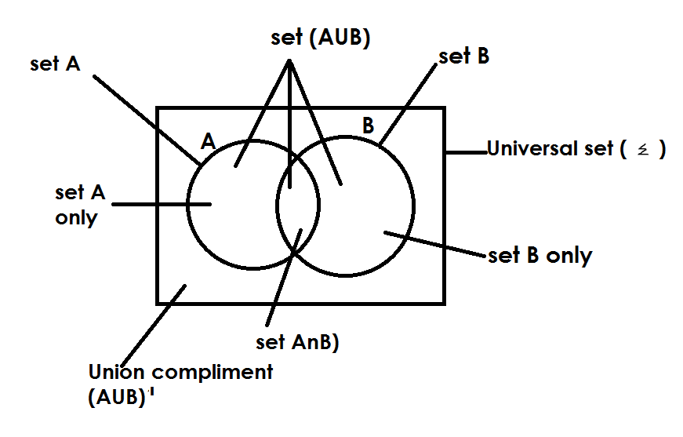

**DESCRIBING SHADED PARTS OF VENN DIAGRAM**

**EXAMPLES**

1) A B 2) **A B**

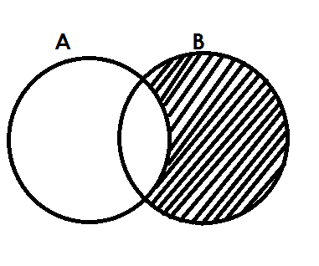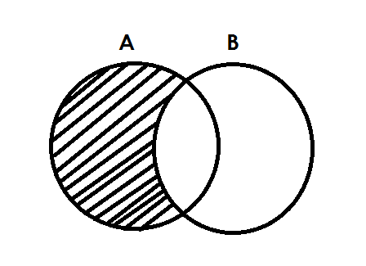 Set A Set B

3) 4)

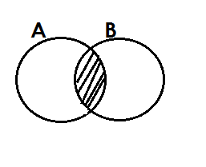 A only / A - B / B1  B only / B – A / A1

5) **A B** 6)

A n B

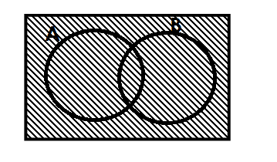7) 8)

A A

(AUB)1 Universal set

9) 10)

B**I**  A**I**

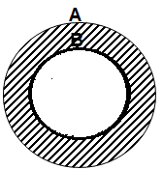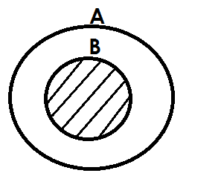 11) 12)

Set B /A∩B A only / B**I**

**ACTIVITY**

1. Describe each of the shaded regions in the venn diagrams below.

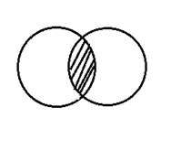(a) P Q (b) K M

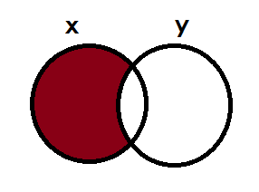

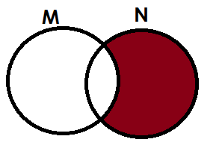(c) (d)

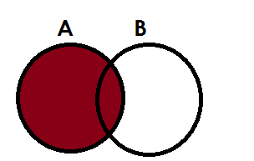(e) (f)

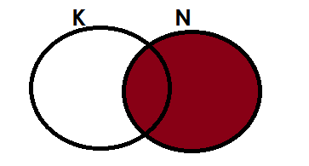

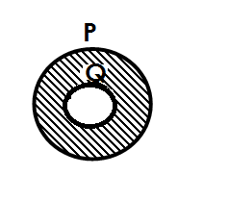

(g) (h) **x**

**y**

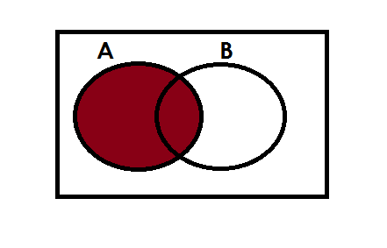(i) (j)

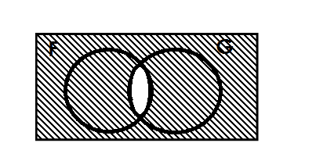(k) (l)

H

**LISTING AND FINDING NUMBER OF ELEMENTS IN A GIVEN SET**

1. Set A = {all factors of 12}

B= {All even members less than 10}

a. Find

(i) A

A = {1, 2, 3, 4, 6, 12}

(ii) B

B = {0, 2, 4, 6, 8}

(iii) (AnB)

AnB = {2, 4, 6}

(iv) AUB

AUB = {1, 2, 3, 4, 6, 12, 0, 8}

b. Find n (A n B)**I**

(AnB)1 = {0, 8, 1, 3, 12}

n (AnB )1 = 5

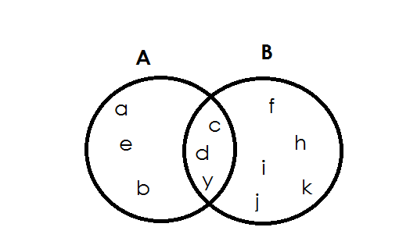2. The venn diagram below shows set A and B.

Find

(i) A

Soln

A = {a, b, e, c, d, y}

(ii) (AnB)1

Soln

(AnB)1 = {a, e, b, f, h, I, j, k}

n (AnB) = 8

(ii) (B – A)

**soln**

B – A = {f, h, I, j, k}

n (B – A) = 5

**ACTIVITY**

1.Given set P = {All multiples of 4 less than 25}

Q = {All factors of 16}

Find (i) P

(ii) Q

(iii) PnQ

(iv) n(PUQ)

2. Given that E= {whole numbers less than 10}

P = {Prime numbers between 1 and 12}

Find (i) E

(ii) n(P)

(iii) n(EnP)

(iv) n(EUP)

3. If set A = {1, 2, 3, 4, 5, 6, 7, 8, 11}

B = {2, 3, 4, 5, 8, 9, 10, 11}

Find (i) AnB

(ii) n(AUB)

(iii) n(A – B)

4. Below is set A and K

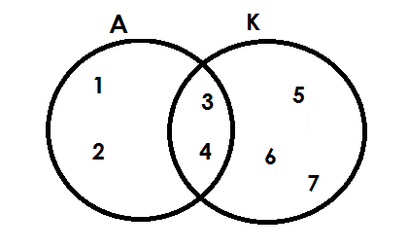

Find

1. A
2. K
3. AnK
4. (AnK)1
5. n(AUK)
6. n(A)1

5. Use the venn diagram below to answer questions.

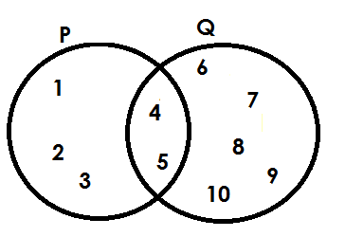

Find (i) P

(ii) Q1

(iii) n(P)1

(iv) n(PnQ)1

**FINDING NUMBER OR ELEMENT ON A VENN DIAGRAM GIVEN GROUPED DATA**

**Note**:

While finding number of elements given grouped data, do not list, we just add.

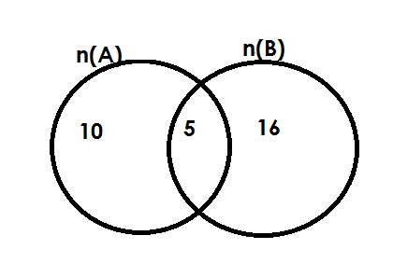Below is set A and B.

Find n (A)

**Soln**

1. n(A) = 10 + 5

= 15

1. n(B)

**Soln**

n(B) = 10 + 15

= 21

(ii) n(AnB)

**Soln**

n(AnB) = 5

1. n(AnB)1

**Soln**

n(AnB)1 = 10 + 16

=2 6

(v) n(AUB)

**Soln**

n(AUB) = 10 + 5 = 16

=31

**Example II**

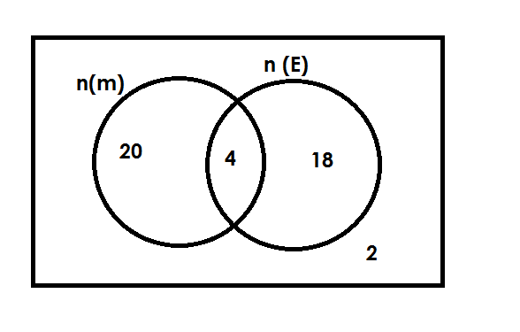The venn diagram below show number of pupils who like Math and English(E)

(a) How many pupils like math (M)

**Soln**

n(m) = 20 + 4

= 24

(b) How many pupils do not like English?

**Soln**

n(E)1 = 20 + 2

= 22

(c) How many pupils like only one subject?

**Soln**

Only one = 20 + 18

= 38

(d) Find the number of pupils in the whole class.

Soln

 n( ) = 20 + 4 + 18 + 12

= 44

**Activity.**

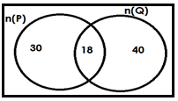1. Below is set P and Q

Find (i) n(P)

(ii) n(PnQ)

(iii) n(PnQ)1

(iv) n(PUQ)

(v) n(P)1

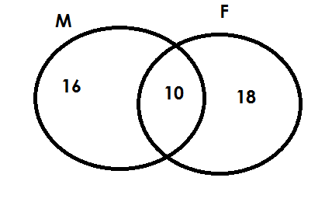2. Below is a set showing number of pupils who like meat (M) and Fish(F)

(a) How many pupils like meat?

(b) Find the number of pupils who like fish?

(c) How many pupils like meant only?

(d) How many pupils are in the whole group?

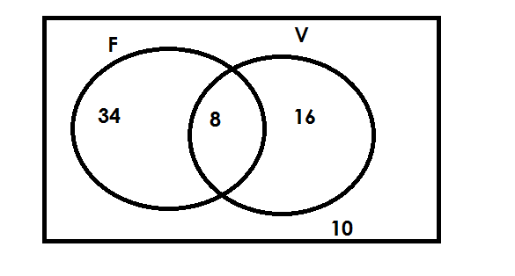3. The venn diagram below show number of pupils who play football (F) and Volley(V)

(a) How many pupils play football?

(b) How many pupils play volley ball?

(c) Find the number of pupils who play only one game.

(d) How many pupils do not play volley ball?

(e) How many pupils do not play football?

(f) How many pupils are in the whole class?

**REPRESENTING INFORMATION ON A VENN DIAGRAMS**

**A. Given ungrouped information.**

**Examples**

1. Give that set A = {1, 2, 3, 4, 5, 6, 7, 8, 9} and

Set B = {All even number less that 12}

a. Find B

B = {0, 2, 4, 6, 8, 12}

b. Show set A and B on a venn diagram.

Soln

A = {1, 2 , 3, 4 , 5, 6 , 7, 8 , 9}

B = {0, 2 , 4 , 6 , 8 ,10}

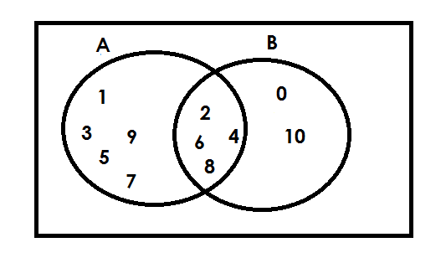

**Examples**

2. If set P = {all prime number less than 12} and

Set K = {all factor of 20}

P = {2, 3, 5, 7, 11}

K = {1, 2, 4, 5, 10, 20}

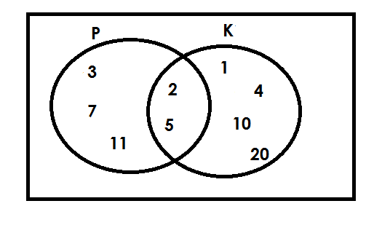

**Activity**

1. Given that T = {Odd numbers less that 10}

U = {odd numbers between 6 and 12}

Show the two sets T and U on a venn diagram.

2. R = {the first five letters of the English alphabets}

S = {vowels in the English alphabet}

Represent set R and Set S on the venn diagram.

3. Set K = {all multiples of 4 less than 25} and

Set T = {even numbers less than 13}

Represent the above information on the venn diagram.

4. Set M= {all factors of 12} and set N = {all multiples of 3 less than 20}

Show set M and set N on a venn diagram.

5. If J = {3, 6, 9, 12} and set K = {all even numbers less than 10}

(a) Find K.

(b) Represent se J and set K on a venn diagram.

6. Given that E = {whole numbers less that 16} and

A = {odd numbers less than 16}

(a) List the members of E

(b) List the members of set A.

**B) Given grouped data**

**Examples**

1. Given that n(A) = 20, n(B) = 15, n(AUB) =10

Show the above information on a venn diagram.

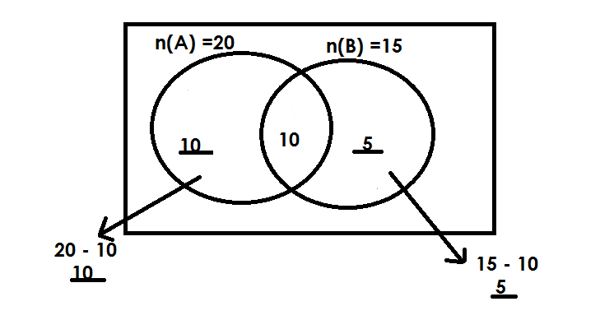 **Soln**

(b) Find n(AUB)

**Soln**

n(AUB) = 10 + 10 + 5

= 25

**Examples II**

2. In a class, 30 pupils like Maths (M), 24 pupils like English(E) and 8 pupils like both subjects.

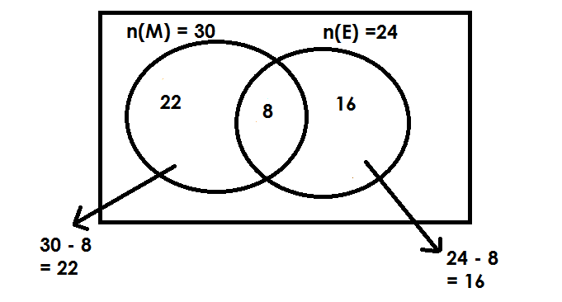a. Complete the venn diagram

(b) How many like math only?

**Soln**

N(M)only = 30 – 8

= 22

2. How many like only one subject?

**Soln**

Only one subject

= 22 + 16

= 38 pupils

**Activity**

1. Given that n(A) = 15, n(B) = 20 and n(AnB) = 9.

a. Draw a venn diagram to represent the above information.

2. The number of pupils who do RE (R) are 26 and the number of pupils who do Art (A) are 30. If there are 16 pupils who do both subjects,

Draw a venn diagram and find out how many pupils do only one subject.

3. If n (M) = 25, n(N) = 20 and n(MnN) = 8.

a. Draw a venn diagram to represent the above information.

(b) Find

(i) n (M – N)

(ii) n (N – M)

(iii) n (N U M)

**SUBSETS**

A subset is a set that can be obtained /formed from any given set.

A symbol for subset is ⊆ (is a subset of)

**Venn diagram about subsets**

**Examples**

Draw a venn diagram to show that all girls are female (F)

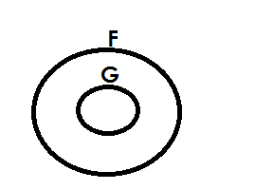 **Soln**

**Examples**

Draw a venn diagram to show that

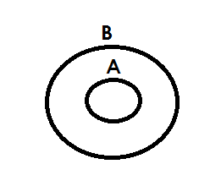 A = A n B

Soln

**Example III**

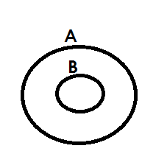 Draw a venn diagram to show that A = AUB

**Activity**

1. Draw a venn diagram to show that all hens(h) are birds(b).

2. Draw a venn diagram to show that all boys(B) are males(M).

3. Draw a venn diagram to show that all goats are are animals.

4. Draw a venn diagram to show that P = PnQ

5. With the help of a venn dram, show that n(K) = n (PUK)

**LISTING SUBSETS**

**Note**:

* An empty set is a subset of every set.
* A given set is a subset of itself.
* Equal sets are not subsets of a given set. e.g. {a, b} and {b, a} since they are taken to be the same.

**Examples**

1. Given that set A = {P}. List all subsets on set A.

**Soln**

{ } , {P}

2. If set P = {1, 2}. List all subsets in set T.

**Soln**

{ } , {1}, {2}, {1, 2}

3. Set Q = {m, a, n}. List all subsets in set Q.

**Soln**

{ }, {m}, {a}, {m, a}, {m, n}, {a, n}, {m, a, n}

**Activity**

1. List all subsets in sets A. If A = { }

2. List all subsets in set Q given that Q = [X, Y}

3. List all subsets in set B with { , , }

4. Given that P is {Mary, Amos, Tony}, write down all subsets of P.

5. Given that M = {cow, goat} write all the subsets of set M.

6. List all subsets is set K if K = { }

**FINDING NUMBERS OF SUBSETS**

No. of subsets = 2**n**

Where 2 shows that number of subsets are in power of 2.

“n” is the number of elements in a given set.

**Examples**

1. Given that A = { }

**Soln**

No. of subsets = 2n

= 20

= 1 subset

2. If set K = {4}, find number of subsets in k.

No. of subsets = 2n

= 23

= 2 x 2 x 2

= 8 subsets

**Activity**

1. Find the number of subsets of set P, given that P = {1, 2, 3, 4}

2. Set Y = {Toad, Frog} Find the number of subset Y.

3. Find the number of subsets of sets X if n(X) = 5.

4. How many subsets are in set W if W = {a}

5. Find the number of subsets in a set with 4 elements.

6. Find the number of subsets in Q given that n(Q) = 1.

7. Use the venn diagram below to answer questions that follow.

a) Find number of subsets in K**I**

b) How many subsets are in set P n K?

c) Find number of subsets in P**I**

**PROBABILITY**

Probability is a measure of chance.

**Note**:

Probability is not reduced.

**Formula**;

Probability = n (D. C)

n (T.C)

Where

D.C Desired chances

T.C Total chances

**TOSSING A COIN**

A coin has two faces ie

1. Head (H)

2. Tail (T)

**Examples**

1. A coin was tossed once. What was the probability of a head showing up?  
 Prob = n (D.C)

n (T.C)

D.C = Head

T.C = 1

T.C = Head, Tail

n (T.C) = 2

Prob = 1

2

**Activity**

1. Richard tossed a coin once. What is the probability that a head shows up?

2. A girl tossed a coin once. What is the probability that a tail shows up?

**ROLLING A DIE**

A die has faces numbered; 1, 2, 3, 4, 5, 6

Pro = n (D.C)

N (T.C)

**Examples**

1. A die was rolled once. What is the probability that,

a) An even number appears on top?

D.C = 2, 4, 6

n (D.C) = 3

T.C = 1, 2, 3, 4, 5, 6

n (T.C) = 6

Prob = 3

6

b) An odd number appears on top.

D.C = 1, 3, 5

n (D.C) = 3

T.C = 1, 2, 3, 4, 5, 6

n (T.C) = 6

Prob =

c) A number greater than 2.

D.C = 3, 4, 5, 6

n (D.C) = 4

T.C = 1, 2, 3, 4, 5, 6

n (T.C) = 6

Prob =

**Activity**

1. A die was tossed once. What is the probability of that?

(a) a prime number appears?

(b) a multiple of 2 appears on top?

(c) a number less than 6 appears top?

(d) a square number appears on top?

(e) a composite number appears on top?

**FINDING PROBABILITY GIVEN ITEMS**

**Examples**

1. In a box, there are 4 black pens and 5 red pens. Find the probability of picking a red pen at random.

**Soln**

n (D.C) = 4

n (T.C) = 4 + 5

= 9

Prob =

2. A bag has 6 red shirts and 5 white shirts. If Mukasa picks one shirt at random from the bag. What is the probability of picking a white shirt?

**Soln**

n (D.C) = 5

n (T.C) = 5 + 6

= 11

Prob =

3. In a class, there are 20 boys and girls. What is the probability of picking a boy to be the class captain?

Soln

Prob = n (D.C)

n (T.C)

n (D.C) = 20

n (T.C) = 30 + 20

 = 50

Prob = 20

50

**Activity**

1. In a basket, there are 6 ripe mangoes and 3 green one Judith picks one mangoes from the bag without looking. What is the probability that she picks a ripe mango?

2. The letters of the word KAMULI were cut separately and put in a bag. What is the probability of picking at random,

a) a vowel?

b) K?

c) a consonant?

3. In a box these are 2 red pens and 3 black pens. What is the probability that a red pen is picked at random from the box?

4. A bag contains 4 blue places and 5 white plates. What is the probability of picking a white plate from the bag?

5. A box contains fruits, 4 passions fruits, 3 oranges and 2 mangoes. What is the chance that an orange fruit is picked from the box at random?

6. What is the probability of picking a black pen from the tin which contains 3 red pens and 6 black pens?

**FINDING PROBABILITY GIVEN DAYS OF THE WEEK**

**Note**:

A week has 7 days. I.e Monday, Tuesday, Wednesday, Thursday, Fridays, Saturday, Sunday.

n (T.C) = 7

1.What is the probability that Musa will go to town on a day which starts with letter S

**Soln**

Prob = n (D.C)

n (T.C)

D.C = Saturday, Sunday

n (D.C) = 2

n (T.C) = 7

Prob =

**Examples**

2. Anthony is going to London. What is the probability that is going on a Tuesday?

**Soln**

D.C = Tuesday

n (D.C) = 1

n (T.C) = 7

Prob =

**Activity**

1. Mr.Kitoko is going for a wedding. What is the probability that he is going on a day which begins with letter T?

2. Agnes is pregnant. If she is expected to give birth next week, what is the probability that she will give birth on Monday?

3. We shall write exams next week. What is the probability that we shall write on a day which begin with letter S?

**FINDING PROBABILITY GIVEN MONTH OF THE YEAR**

**NOTE**:

A year has 12 months i.e January, February, March, April, May, June, July, August, September, October, November and December.

Number of total chances is 12.

**Example I**

We shall go to Kampala next year, what is the probability the we shall go in a month starting with letter J?

D.C = January, June , July

n (D.C) = 3

n (TC) = 7

Prob = n (D.C)

n (T.C)

=

**Example ll**

Matame is wedding next year, what is the probability that she will wed in April.

D.C = April

n (D.C) = 1

n (T.C) = 12

Prob = n (D.C)

n (T.C)

=

**Activity**

1. Primary leaving examination will be done next year, what is the probability that the examination will be done in the month starting with letter J?

2. What is the probability that Uganda will receive heavy rainfall in the month starting with letter “m”?

3. All government teachers will be paid next year, what is the probability that the payment will be than in the first 3 month of the year.

4. The official election of president will take place next year, what is the probability that will take place in the month starting with letter A?

5. A pregnant mother will give birth next year. What is the probability that it will be in the month of May?

**FINDING PROBABILITY INVOLVING FRACTIONS**

**Example I**

The probability that he will pass his examination is . What is the probability that he will fail?

**Soln**

Passing =

Failing = 1 -

***= -***

***=***

**Example II**

The probability that we shall get food tomorrow is 0.8 what is the probability that we shall not get.

Getting = 0.8

Not getting = 1 – 0.8

=

=

= 0.2

**Activity**

1. The probability that it will rain today is . What is the probability that it will not rain?

2. The probability of passing exams is find the probability of failing.

3. The probability that school in Uganda will reopen next month due to covid 19 pandemic is . What is the probability that the schools will not open?

4. The probability that Musa will pass an interview is 0.4. What is the probability that he will not pass it?

5. The chance that president Museveni will be voted back in power is 0.6. What is the probability that he will not be voted into power?

**WHOLE NUMBERS.**

**NUMERATION SYSTEMS AND PLACE VALUES.**

**Finding place valves of whole numbers.**

A place valves is a position of a digit in a given number.

**Example I**

Find the place value of each digition the number below.

5 4 6 8 9 10

**Soln**

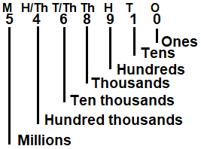

**Example II**

What is the place value of the underlined digits in 4 8 9 4 7 2

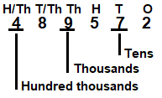**Soln**

**Activity**

1. What is the place valUe of each of the digits in the following.

(a) 5403 (b) 72483 (c) 169542

(d) 623,589 (e) 1689143 (f) 942376

(2) What is the place value of the underlined digits in the following.

(a) 1 4 83 (b) 964324 (c) 79462

(d) 38946 (e) 76421 (f) 846241

**FINDING VALUE OF DIGITS IN WHOLE NUMBERS.**

A value is a product of a digit and its place value.

**Example I**

Find the each of the digits in 4 6 8 2 4 5 9

**Soln**

**M HT TTH TH H T O**

**4 6 8 2 4 5 9**

**9 x 1 = 9**

**5 x 10 = 50**

**4 x 100 = 400**

**2 x 1000 = 2000**

**8 x 10, 000 = 80,000**

**6 x 100, 0000= 600,000**

**4 x 1000, 000= 4, 000, 000**

**Example II**

What is the value of the underlined digits in 19 8 4 0 3 6?

**M H/Th T/Th Th H T O**

1 9 8 4 0 3 6

0 X 100 = 0

8 X 10,000 = 80,000

**Activity**

1. What is the value of each of the following digits?

(a) 4 03 (b) 97036 (c) 342634 (d) 90786

2. What is the value of the underlined digit.

(a) 3 0 4 (b) 97043 (c) 4 0 3007

3. What is the value of the underlined digit.

(a) 4097 (b) 99043 (c) 102973

4. Expand 406 using value.

**EXPANDING WHOLE NUMBERS**

(A) **USING PLACES VALUES.**

(a) Expand 7437 using place values.

**TH H T O**

7 4 3 7

= (7 X 1000) + (4 X 100) + (3 X 10) + (7 X 1)

(b) Express 697,636 in expanded form using place values

**HTH TTH TH H T O**

6 9 7 6 3 6

= (6 X100,000) + (9 X 10,000) + (7 X 1000) + 6 X 100) + (3 X 10) + (6 X 1)

**ACTIVITY**

1. Expand 9464 using place values.

2. Express 46,367 in expanded from using place values.

3. Expand the following numbers using place values.

(a) 369 (b) 489,630 (c) 346,001 (d) 496,304 (e) 496,346

(B) **USING VALUES**

**Examples**

1. Expand 4051 using values.

**Soln**

**TH H T O**

4 0 5 1

= (4 x 1000) + (0 x 100) + (5 x 10) + (1 x 1)

= 4000 + 0 + 50 + 1

2. Write 817,036 in expanded form using values.

**Soln**

**HTH TTH TH T H O**

8 1 7 0 3 6

= (8 X 100, 000 + (1 X 10, 000) + (7 X 10, 000) + (0 X 100) + (3 X 10) + (6 X 1)

= 800,000 + 10,000 + 7,000 + 0 + 30 + 6

3. Expand 90760 using values.

**Soln**

**T/Th TH H T O**

9 0 7 6 0

= (9 X 10,000) + (0 X 1000) + (7 X 100) + (6 X 10) + (0 X 1)

= 90,000 + 0 + 700 + 60 + 0

**Activity**

1. Expand 3049 using values.

2. Express 90347 in expanded form using values.

3. Expand the following numbers.

(a) 304 (b) 4906 (c) 490,763

(d) 396,003 (e) 96,364 (f) 304,304

**EXPANDING NUMBERS USING POWERS / INDICES/ EXPONENTS**

**Examples.**

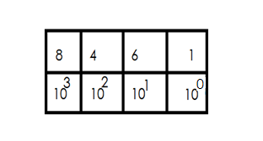1. Expand 8461 using powers

= (8 x 10 3) + (4 x 10 2) + (6 x 101) + (1 x 100)

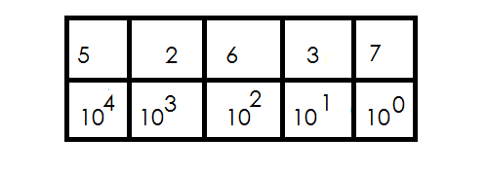2. Express 52637 in expanded form using exponents.

= (5 x 10 4) + (2 x 103) + (6 x 102) + (3 x101) + (7 x100)

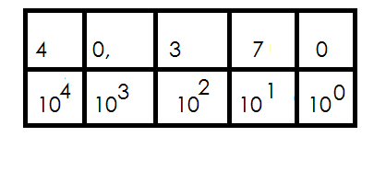3. Expand 40,370 using exponents indices.

= (4 x 104) + (0 x 103) + (3 x 102) + (7 x101) + (0 x 100)

**Activity**

1. Expand 304 using powers.

2. Express 46,763 in expanded form using exponents.

3. Expand 503466 using indices.

4. Expand the following numbers using powers.

(a) 30,467 (b) 340,067

(c) 490,363 (d) 963,679

**FINDING EXPANDED NUMBER**

**Examples**

1. Express (5 x 100000) + (6 x10000) + (9 x1000) + (4 x 10) as single number.

**Soln**

= 500,000 + 60,000 + 9,000 + 40

500,000

60,000

9, 000

+ 40

569,040

2. What number has been expanded to give: 40,000 + 9000+ 800 + 2?

40,000

9,000

800

+ 2

49,802

3. Write the expanded number in short

= (2 x 10 4) + (8 x 103) + (5 x 102) + (3 x 100)

= (2 x 10 x 10 x 10 x 10) + (8 x 10 x 10 x 10) + (5 x10 x 10) + (3 x 1)

= (2 x 10000) + (8 x 1000) + (5 x 100) + (3 x1)

= 20000 + 8000 + 5 00 + 3

20,000

8,000

500

+ 3

28,503

4. What number was expanded to give. (3 x 10,000) + (2 x 10)

**Soln**

30, 000 + 20

30, 000

+ 20

30,020

5. What number was expanded to give.

= (3 x 10**4**) + (5 x 10**2**) + (4 x 100)

= (3 x 10 x 10 x 10 x 10) + (5 x10 x 10) + (4 x1)

= (3 x 10,000) + (5 x100) + (4 x1)

= 30,000 + 500 + 4

30,000

500

+ 4

30,504

**Activity**

1. What number has been expanded to give.

(a) (9 x 1000) + (3 x 100) + (2 x10) + (1 x 1)

(b) (8 x 100,000) + (7 x 10,000) + (2 x 100) + (2 x 1)

(c) (5 x 100,000) + (6 x 100) + (4 x 1)

2. Write the expanded number in short.

(a) 30,000 + 900 + 3

(b) 9,000,000 + 700,000 + 40

3. What number was expanded to give.

(a) (9 x 103) + (4 x102) + (2 x 101) + (5 x 100)

(b) (6 x 104) + (4 x102) + (3 x101) + (0 x100)

(c) (9 x 104) + (3 x 101) + (4 x100)

**WRITING FIGURES IN WORDS**

**Examples**

1. Write 36,948 in words.

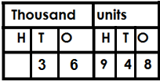 **Soln**

Thirty-six thousand, nine hundred forty-eight.

2. Write 730,609 in words.

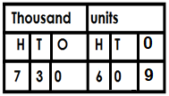 **Soln.**

Seven hundred thirty thousand, six hundred nine.

3. Write 1,403,604 in words

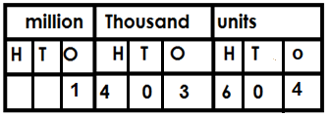 **Soln**

One million, four hundred three thousand, six hundred four.

**Activity**

Write the following in words.

(a) 409 (b) 9463

(c) 97,063 (d) 376489

(e) 17,036 (f) 963468

**WRITING NUMBER WORDS IN FIGURES**

1. Write Twelve thousand four in figures.

Twelve thousand 12,000

Four. + 4

12,004

2. Write five hundred twenty – one in figure

Five hundred 500

Twenty-one + 21

521

3. Write four hundred three thousand six hundred twenty in figures.

Four hundred three thousand 403,000

Six hundred. 600

Twenty. + 20

403, 620

4. Write in figures: Five million, four hundred four thousand, seven hundred sixteen

Five million. 5,000,000

Five hundred five thousand. 505,000

Five hundred. 500

Fifteen. + 15

5,505, 515

**Activity**

Write the following in figures

(a) Eleven thousand, six hundred eleven.

(b) Eighteen thousand, five hundred twenty-six.

(c) Ninety – seven thousand, eighteen.

(d) One hundred fifty thousand twenty.

(e) One hundred thousand, one

(f) One hundred one thousand one hundred one

(g) Six million, nine hundred thousand ten

**FORMING NUMERALS FROM DIGITS**

**Note**:

* There is no number that starts with digit zero.
* No commas should be indicted in the number formed.
* When forming the smallest numeral, arrange the given digits in ascending order but without commas.
* When forming the biggest numeral arrange the given digits in descending order but without commas.

**Examples I**

1. Given digits 2, 3 and 4 form all the three digits numerals

2 3 4

234 324 433

The numbers are 234, 243, 324, 342, 423, 432.

2. Given 4, 0 and 8:

(a) Form the smallest numeral using the above digits.

The smallest numeral = 408

(b) Form the biggest numeral using the above digits.

The biggest numeral = 840

(c) Find the difference between the biggest and smallest numbers formed.

**Soln**

Biggest = 8 40

Smallest = - 4 0 8

Difference 4 3 2

3. Given the digits 9, 0 and 4

(a) Form all the possible three-digit numerals using the above digits.

**Soln**

|  |  |  |
| --- | --- | --- |
| 0 | 4 | 9 |
|  | 409 | 904 |
|  | 490 | 940 |

The numerals are; 409, 490, 904, 940.

4. Given the digits: 4, 0, 2 and 6.

(a) Form the biggest four digit numeral.

**Soln**

Biggest numeral = 6420

(b) Form the smallest numeral.

**Soln**

Smallest numeral = 2046

(c) Find the sum of the biggest and the smallest numerals formed.

Biggest numeral 6420

Smallest numeral 2046

Sum +8466

**Activity**

1. Given the digits 7, 3 and 5.

(a) Form the smallest three-digit number.

(b) Form the biggest three-digit numeral.

(c) Find the sum of the smallest and biggest numerals formed.

2. Given the digits: 9, 1 and 2.

(a) Form the smallest three digits numeral.

(b) Form the biggest three-digit numeral.

(c) Work out the sum of the smallest and the biggest numerals formed.

(d) Find the difference of the biggest and smallest three-digit numerals formed.

(e) Express the smallest three-digit numeral in expanded form.

3. Use 5, 0 and 8 to form all three-digit numerals.

4. Given digits 7, 6 and 9,

a) Form all the three digits numerals.

b) Find the difference of the biggest and the smallest numerals formed.

**DECIMAL FRACTIONS**

A decimal number is a number with a decimal point and decimal places.

**Forexample;**

0.8, 0.108, 0.0072, 12.35, 0.2727, 1.66 etc.

**Illustration of a decimal number by its composition.**

Whole digits Decimal digits

1 2 4 0 7 5

Decimal point

**Place value of decimal numbers.**

**Note:**

All place values of decimal digits end in **“ths”**

**Examples of decimal place values include;**

1. Tenths (Tths)

2. Hundredths (Hths)

3. Thousandths (Thths)

4. Ten thousandths (T/Thths)

5. Hundred thousandths (H/Thths)

**Examples**

1. Write the places values of each digits in 124.075

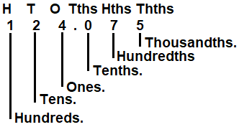 **Soln**

2. Write the place values of 2 in 0.42

**Soln**

0 Tths Hths

0 . 4 2

Hundredths

3. Find the place value of 3 in 37.59

**Soln**

T O Tth Hths

3 7. 5 9

Tens

**Activity**

1. Find the place values of each digits in 25.047

2. Find the place value of the underlined digits.

(a) 0.75

(b) 6.03

(c) 0.123

(d) 75.03

(e) 109.01

3. What is the place value of 7 in 726.04?  
4. Write the place value of 0 in 2.705.

**VALUES OF DECIMALS**

**Note:**

Value is the product of a digit and its place value?

**Examples**

1. Find the value of each digits in the number 251.039.

H T O Tths Hths Thths

2 5 1 . 0 3 9

9 x 1 = 9

1000 1000

= 0.009

3 x 1 = 3

100 100

= 0.03

0 x 0 = 0

10

1 x 1 = 1

5 x 10 = 50

2 x 100 = 200

2. What is the value of 5 in 0.05.

**Soln**

O Tths Hths

1. 0 5

= 5 x 1 =5

100 100

= 0.0 5

3. Find the value of 3 in the number 37.1.

**Soln**

**T O Tths**

3 7. 1

= 3 X 10

= 30

**Activity**

1. Write the value of every digit in 70.12

2. Find the value of each digit in 0.027.

3. Find the value of the underlined digit.

(a) 0.5

(b) 7.65

(c) 23.08

(d) 2.05.

(e) 0.234

(f) 801.95

**EXPANDING DECIMALS**

**(a) Using place values.**

**Examples**

Expand 4.32 using place values.

Soln

**O TH HTHS**

4 . 3 2

(4 X 10) + (3 X ) + (2 X )

**Example II**

Expand 34.204 using place values.

T O Tths Hths Tths

3 4 . 2 0 4

= (3 X 10) + (4 X 10) 2 X ) + (0 X ) + (4 X )

Expand 434.24 using place values.

**Soln:**

**H T O Tths Hths**

4 3 4 . 0 2

= (4 x 1000) + (3 x 10) + (4 x 1) + (0 x ) + (2 x )

**ACTIVITY**

1. Expand 42.3 using place values.

2. Expand 69.24 using place values.

3. Expand the following using places values.

(a) 30.4

(b) 342.52

(c) 97.304

(d) 402.34

**(b) Using values.**

**Examples**

Expand 32.4 using values

**Soln**.

**T O Tths**

3 2 . 4

= (3 x 10) + (2 x 10) + (4 x )

= (3 x 10) + (2 x 10) + ()

= 30 + 2 + 0.4

Expand 69.23 using values.

**Soln**

**T O Tths Hths**

6 9 . 2 3

= (6 x 10) + (9 x 1) + (2 x ) + (3 x )

= 60 + 9 + +

= 60 + 9 + 0.2 + 0.03

Expand 6.306 using values

Soln

O Tths HthsTths

6 . 3 0 6

= (6 x 1) + (3 x ) + (0 x ) + (6 x )

= 6 + 0.3 + 0 + 0.006

**Activity**

1. Expand 0.32 using values.

2. Expand the following using values.

(a) 2.3

(b) 2.03

(c) 42.59

(d) 421.3

(e) 39.462

(c)  **Using powers/exponents /indices.**

**Example I**

Expand 49.5 using powers.

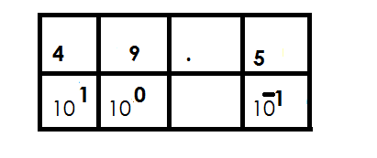 **Soln.**

= (4 x 10**1**) + (9 x 10**0**) + (5 x 10**-1**)

Expand 59.463 using powers.

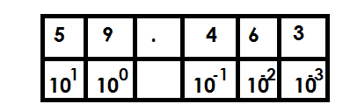**Soln**

= (5 x 10**1**) + (9 x 10**0**) + (4 x 10**-1**) + (6 x 10**-2**) + (3 x 10**-3**)

**Example III**

Expand 402 .42 using indices.

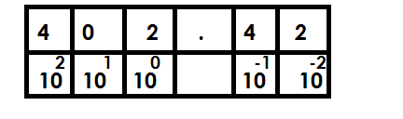**Soln**

= (4 x 10**2**) + (0 x 10**1**) + (2 x 10**0**) + (4 x 10**-1**) + (2 x10**-2**)

**Activity**

1. Expand 49.3 using powers.

2. Expand 56.03 using exponents.

3. Expand 4.93 using indices.

4. Expand the following using powers.

(a) 4.9

(b) 0.49

(c) 54.3

(d) 67.07

(e) 78.067

**WRITING DECIMALS IN WORDS**

**Example I**

1. Write 0.3 in words

0.3 zero point three

**Or**

O T th

0 . 3 Three tenths

**Example II**

2. Write 4.32 in words

**Soln**

4.32 four point three two.

**Or**

Hths

4. 32 4 and 32

Hundredths

Four and thirty-two hundredths

**Example III**

3. Write 402.463 in words

Soln

402. 463 402 and 463

Thousandths

Four hundred two and four hundred sixty-three thousandths

**Example IV**

4. Write 32.04 in words

**Soln**

32.04 32 and 4

Hundredths

Thirty-two and four hundredths

**Activity**

1. Write the following in words

(a) 40.3

(b) 58.69

(c) 403.52

(d) 40.32

(e) 56.03

(f) 403.5

**WRITING DECIMALS IN FIGURES**

**Example I**

1. Write in figures. Four tenths

Four tenth 4

10

= 0.4

**Example II**

2. Write forty – nine and four tenths in figures.

**Soln**

Forty – nine and four tenths 49.4

**Examples III**

3. Write three hundred four point five six in figures.

**Soln**

304.56

**Example IV**

4. Write Thirty – nine and six hundred five thousandths.

**Soln**

Thirty-nine 39 and 605

39.605

**Activity**

1. Write the following decimals in figures.

(a) Two tenths

(b) Five and six tenths

(c) Four and thirty – nine hundredths

(d) Seven hundred two and four hundredths

(e) Sixty-eight point four five six

(f) Four and five hundred fifty – six thousandths

**ROMANS NUMERALS**

**Number**

Is the quantity of something.

**Numeral**

Is a symbol that represents a number.

**TYPES OF NUMERALS**

1. Hindu Arabic numerals.

2. Roman numerals

**HINDU ARABIC NUMERALS**

These are numerals that are used in most parts of the world.

Major Hindu Arabic numerals.

0, 1, 2, 3, 4, 5, 6, 7, 8, 9

**ROMAN NUMERALS**

1. Basic Roman Numeral

|  |  |  |  |  |  |  |  |  |
| --- | --- | --- | --- | --- | --- | --- | --- | --- |
| **Hindu Arabic** | **1** | **5** | **10** | **10** | **50** | **100** | **500** | **1000** |
| **Roman Numeral** | **1** | **V** | **X** | **X** | **L** | **C** | **C** | **M** |

All Roma numerals should be written in capital letters.

**2. Repeated Roman numerals.**

Roman Numerals got by repeating **I**

2 = II

3 = III

Roman Numerals got by repeating X

20 = XX

30 = XXX

Roman Numerals got by repeating C

200 = CC

300 = CCC

Roman Numerals got by repeating M

200 = MM

3000 = MMM

**NB :**The above repeated numerals start with digits 2 or 3.

**3. Roman Numerals got by adding 5, 50 or 500**

**NB.**

These always start with digits 6, 7 or 8.

**Examples**

6 = 5 + 1

= VI

7 = 5 + 2

= VII

8 = 5 + 3

= VIII

60 = 50 + 10

= LX

70 = 50 + 20

= LXX

80 = 50 + 30

= LXXX

600 = 500 + 100

= DC

700 = 500 + 200

= DCC

800 = 500 + 300

= DCCC

**4. Roman Numerals got by subtracting from 5, 10, 50, 100 or 1000.**

**NB**

These always start with digits 4 and 9.

**Examples**

4 = 5 – 1

= IV

9 = 10 – 1

= IX

40 = 50 – 10

= XL

90 = 100 – 10

= XC

400 = 500 – 100

= CD

900 = 1000 – 100

= CM

**Hindu Arabic and Roman numerals**

|  |  |
| --- | --- |
| **Hindu Arabic** | **Roman Numeral** |
| 1 | I |
| 2 | II |
| 3 | III |
| 4 | IV |
| 5 | V |
| 6 | VI |
| 7 | VII |
| 8 | VIII |
| 9 | IX |
| 10 | X |
| 20 | XX |
| 30 | XXX |
| 40 | XL |
| 50 | L |
| 60 | LX |
| 70 | LXX |
| 80 | LXXX |
| 90 | XC |
| 100 | C |
| 200 | CC |
| 300 | CCC |
| 400 | CD |
| 500 | D |
| 600 | DC |
| 700 | DCC |
| 800 | DCCC |
| 900 | CM |
| 1000 | M |
| 2000 | MM |
| 3000 | MMM |

**CHANGING HINDU ARABIC NUMERALS TO ROMAN NUMERALS**

**Examples**

1. Express 19 in Roman Numerals

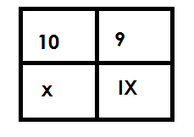 Soln

19 =

= XIX

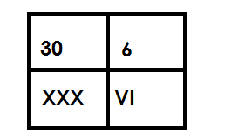2. Change 36 to Roman numerals.

36 =

= XXXVI

3. Change 69 to Roman numerals

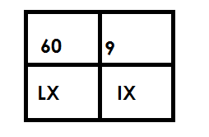 69 =

= LXIX

**Activity**

Change the following Hindu Arabic numerals to Roman numerals.

1. 14
2. 8
3. 23
4. 17
5. 49
6. 89
7. 199
8. 123
9. 449
10. 968
11. 888

**CHANGING ROMAN NUMERALS TO HINDU ARABIC NUMERALS**

**Examples**

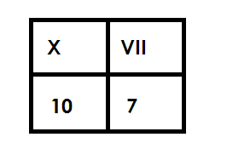1. Change XVII to Hindu Arabic Numerals

XVII =

= 17

2. Express XCVIII to Hindu Arabic numeral.

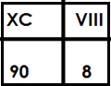 **Soln**

XCVIII =

= 90 + 8

= 98

3. Convert DCCLXXXVIII into Hindu Arabic numeral

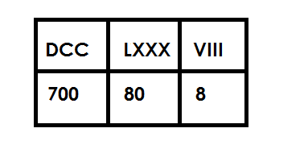 **Soln**

DCCLXXXVIII =

= 700 + 80 + 8

= 788

**Activity**

1. Change the following from Roman Numerals to Hindu Arabic numerals.

(a) XI

(b) LVIII

(c) XCIII

(d) CXXIV

(e) CCCLXIII

(f) DCCXX

(g) DCCCLXXXVIII

(h) CMXXII

(I) CMIX

**WORD PROBLEMS INVOLVING ROMAN NUMERALS AND HINDU ARABIC NUMERALS**

**Examples**

1. Musoke is 9 years. Write his age in Roman numerals.

**Soln**

9 = IX

2. Mukuba scored 54 marks in a test. Write score in Roman numerals.

**Soln**

54 = 50 + 4

LIX

3. There are are XLIV oranges and LVIII apples in a basket. Find the total number of fruits in the basket in Hindu Arabic numerals.

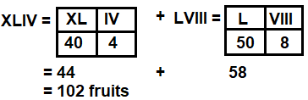

**Activity**

1. A basket contains 23 ripe mangoes. Write the number of mangoes in the baskets in Roman numerals.

2. Mukiibi is 49 years. Express his age in Roman numerals.

3. Katongole has XVIII children. Write his number of children in Hindu Arabic numerals

4. There are XLVIII English books in the library. Express the number of books in Hindu Arabic numerals.

5. Malevu was born in MCMXCII. Write his year of birth in Hindu Arabic numerals.

**ROUNDING OFF**

This is a way of approximating numbers to the required place value.

**Rounding off of whole numbers**

* In rounding off, consider the digit on the right of the figure in the required place value to either **round up** or **round down**.
* Round down incase the digit on the right of the figure in the required place value is either 0, 1, 2, 3 or 4 by adding zero (0) to the digit in the required place value.
* Round up incase the digit on the right of the figure in the required place value is either 5, 6, 7, 8 or 9 by adding 1 to the digit in the required place value.
* All digits coming on the right of the digit in the required place value will turn into zero (0) when rounding off whole numbers.

**Examples**

1. Round off 24643 to the nearest hundreds

**Soln**

Tth Th H T O

2 4 6 4 3

+ 0

2 4 6 0 0

 24643 24600

2. Round off 4896 to the nearest hundredths

Soln

**Th H T O**

4 8 9 6

+ 1 0 0

4 9 0 0



4896 4900

3. Round off 68 to the nearest hundreds

**H T O**

0 6 8

+ 1 0 0

 1 0 0

 68 100

**Activity**

1. Round off the following to the nearest tens.

(a) 4642

(b) 314

(c) 489

(d) 835

(d) 9

2. Round off the following to the nearest hundredths

(a) 4380

(b) 229

(c) 56

(d) 7

(e) 4

3. Round off the following to the nearest thousands.

(a) 4687 (e) 14324

(b) 96894 (f) 246

(c) 743214 (g) 994

(d) 49684

**ROUND OFF DECIMALS**

**Note:**

* All digits coming on the right of the digit in the required place value are

crossed out.

* The last digit should be in the mentioned place value.
* Round off to 2 decimal places means hundredths, one decimal tenths

whole number means one places value.

**Examples**

1. Round off 34.56 to the nearest tenth

**Soln**

RD

3 4 . 5 6

+ 0 . 1

3 4 . 6 

34. 56 34.6

2. Round off 36.764 to the two decimal places

RD

3 6 . 7 6 4

+ 0 . 0 0

3 6 . 7 6



 36.76 36.76

**Examples III**

Round off 49.98 to the nearest whole number

**Soln**

RD

4 9 . 9 8

+ 1

 5 0

38. 46 38.5

**Example v**

Round off 7 6 . 4 8 3 to 2 decimal places

Soln

7 6 . 4 8 3

+ 0

7 6 . 48

76.48 76.48

Round off 146.58 to the nearest tens.

**Soln**

RD

1 4 6 58

+ 1 0

1 5 0

146.58 150

**Activity**

3. Round off 46.58 to the nearest tenths.

4. Round off 98.407 to the nearest hundredths.

5. Correct 98.478 to 1 decimal place.

6. Round off 90.861 to the nearest whole number.

7. Round off 67.567 to 2 decimal places.

8. Round off 105.69 to the nearest tens.

9. Round off 148.79 to the nearest tenths.

1. Round of the following to the nearest tenths.

(a) 40.66 (b) 99.90 (c) 507.48

Round off the following to the nearest hundredths.

2a. 59.698 (b) 147.498 (c) 449.467

**OPERATIONS ON WHOLE NUMBERS.**

**ADDITION OF NUMBERS**

**Example I**

Add: 434126 + 12431

**Soln**

4 3 4 1 2 6

+ 1 2 4 3 1

4 4 6 5 5 7

**Example II**

Add: 7 6 4 3 2 + 6 8 9 7

**Soln**

7 6 4 3 2

+ 6 8 9 7

7 3 3 2 9

**Example III**

**Work out** : 84399 + 46784

8 4 3 9 9

+ 4 6 7 8 4

13 3 1 1 8 3

**Activity**

1. Add: 35643 + 12432

2. Add: 432143 + 12344

3. Add: 49986 + 12344

4. Add: 598975 + 146789

5. Add: 4 6 9 5 8 9

+ 3 7 8 9 9 9

6. Add: 1 4 6 5 8 9

+1 3 4 5 9 5

7. Add: 498999 + 110111

**WORD PROBLEMS INVOLVING ADDITION OF WHOLE NUMBER**

**Note**:

Sum is the result of addition.

Observe units used in the question.

**Example I**

In school there are 467 boys and 622 girls. How many pupils are in the school?

Soln

No. of pupils = 4 6 7

+ 6 2 2

10 8 9 pupils



1089 pupils

**Examples II**

There are 24361 books in the library and 12431, more books were donated to the same library. How many books are there altogether?

**Soln**

2 4 3 6 1

+ 1 2 4 3 1

3 6 7 9 2 books.

**Activity**

1. Add: 48.685 + 89.637

2. What is the sum of 52132 and 93452?

3. Containers A and B have 98456 litres and 45,631 litres of petrol respectively. How much fuel is in the containers altogether?

4. In a region, there are 672,165 women and 489,520 girls. What is the total number of females in the region altogether?

5. A school collected sh.4,586,850 in March and sh 3,950, 980 in April. What was the total of collection in the two months?

6. 853,840ml of juice was consumed in February and 5,950,850 in March. How much juice was consumed in the two months?

7. There are 658,165 pencils in one box and 789,968 in another. What is the total number of pencils in the two boxes?

**SUBTRATION OF WHOLE NUMBER**

**Example I**

Subtrac: 4734 – 2412

**Soln**

4 7 3 4

- 2 4 1 2

2 3 2 2

**Example II**

5 13 11 1

**Work out** : 7 6 4 2 4

1 9 8 6

7 4 4 3 8

**Example III**

4 11 12

**Subtract** : 5 2 3 3 1 8 6

- 1 3 4 5 1 0 2

3 8 8 8 0 8 4

**Activity.**

Workout the following.

* 1. 678,028 – 498,762
  2. 340,018 – 67,823
  3. 567,489,037 – 345,467,254
  4. 86421357 – 1358642
  5. 6789054 – 3450287
  6. 598975 – 146789
  7. 432143 – 12344

**WORD PROBLEMS INVOLVING SUBTRACTION OF WHOLE NUMBERS.**

**Note**:

Difference is the result after subtracting.

**Example I**

Subtract 857, 575 from 987628

**Soln**

**5**

9 8 7 6 2 8

* 8 9 7 5 7 5

1 3 0 0 5 3

**Example II**

Find the difference between 1,650, 922 and 769,866

**Soln**

15 14 8 1 1

6 5 0 9 2 2

7 6 9 8 6 6

8 8 1 0 5 6

**Example III**

A farmer had 984636 animals and 462462 died, how many animals remained on the farm.

Remaining 9 8 9 6 3 6

animals 4 6 2 4 6 2

5 2 2 1 7 4

**Example III**

A diary processed 6,500,650 litres of milk and sold 5,650,945 litres. How many litres were left?

5 14 9 9 4

A mount of left 6 5 0 0 6 5 0

5 6 5 0 9 4 5

8 4 9 , 7 0 5 litres

849,705 litres were left

**Activity**

1. Subtract 769,866 from 1,650,922

2. What is the difference between 924568 and 295,877.

3. Subtract: 2,894,052 from 7,014,263

4. Akello’s salary sh 1,240,750. It was reduced by sh 89,850. How much does he get now?

5. Out of 2,045,000kg of maize 987,565kg are sold. How many kg remained?

6. The number of cows in a district were 8,004,566 but 595,878 were slaughtered.

How many cows remained?

7. There were one million chicken on Musa’s farm 950,755 were sold on Idd day. How many remained?

**MULTIPLICATION OF WHOLE NUMBERS**

**Example I**

1. Multiply:1 4 2 x 1 2

**Soln**

1 4 2

X 1 2

2 8 4

+1 4 2 0

1 7 0 4

**Example II**

2. **Workout**  3 5

X 1 2

7 0

+ 3 5 0

4 2 0

3. **Example III**

**Multiply**  2 4 9 x 32

**Soln**

2 4 9

X 3 2

4 9 8

7 4 7 0

7 9 6 8

**Activity**

Multiply the following

1. 28 x 11

2. 34 x 12

3. 56 x 23

4. 45 x 25

5. 247 x 23

6. 897 x 42

7. 409 x 73

8. 312 x 25

9. 565 x 20

**WORD PROBLEMS INVOLVING MULTIPLICATION OF WHOLE NUMBERS.**

**Note**:

Product is the result of multiplication

4 x 3 = 12

Multiplicand Multiplier Product or multiple

**Examples**

1. Multiply: 2 2 5 by 14

2 2 5

X 1 4

9 0 0

+ 2 2 5 0

3 1 5 0

2. There are 125 boxes of soap. Each box contains 25 bars of soap. How many bars of soap are there?

1 2 5

x 2 5

7 2 5

+ 2 5 0 0

3 2 2 5 bars of soap

**Activity**

1. Multiply 179 by 19.

2. What is the product of 69 and 76?

3. Find the product of 432 and 63.

4. Multiply 245 by 45.

5. How many pupils are in 33 classrooms if each classroom has 109 pupils?

6. How many nails will 50 boxes hold if each box holds 800 nails?

7. A rectangular garden measure 332 metres by 56 metres. What is the area of the garden in square metre?

8. Fine the area of a rectangular piece of paper whose sides are 42cm by 24cm.

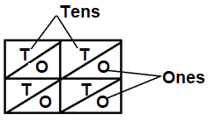**MULTIPICATION OF WNOLE NUMBERS USING LATTICE METHOD.**

**Note**



Or

**Examples**

Multiply 2 4 x 12 using lattice method.

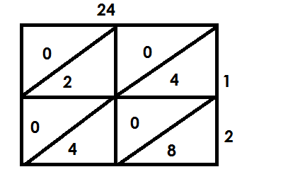 **Soln**



24 x 12 = 288

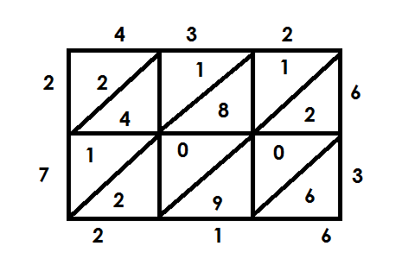2. Multiply 4 3 2 x 6 3 using lattice method.



432 x 63 = 27216

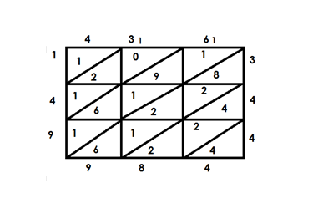3. Multiply: 4 3 6 x 3 4 4

 436 x 344 = 149984

**Activity.**

**Multiply the following using lattice method.**

1. 89 x 45

2. 75 x 25

3. 351 x 15

4. 349 x 23

5. 413 x 514

6. 565 x 204

**DIVISION OF WHOLE NUMBERS**

**a) Working of division using repeated subtraction.**

**Examples**

1. Work out 35 ÷ 5 using repeated subtraction

**Soln**

35 ÷ 5 3 5 - 5 = 30

30 - 5 = 25

25 - 5 = 20

20 - 5 = 15

15 - 5 = 10

10 - 5 = 5

5 - 5 = 0

35 ÷ 5 = 7

2. Work out 49 ÷ 7 using subtraction.

**Soln**

49 ÷ 7 49 - 7 = 42

42 - 7 = 35

35 - 7 = 28

28 - 7 = 21

21 - 7 = 14

14 - 7 = 7

7 - 7 = 0

49 ÷ 7 = 7

3. Simplify 63 ÷ 7 using repeated subtraction.

**Soln**

63 ÷ 7 = 63 - 7 = 56 14 - 7 = 7

56 - 7 = 49 7 – 7 = 0

49 - 7 = 42

42 – 7 = 35 9 times

 35 – 7 = 28

28 – 7 = 21 63 ÷ 7 = 9

21 – 7 = 14

**Activity**

Work out the following using repeated subtraction.

(a) 72 ÷ 9

(b) 16 ÷ 4

(c) 32 ÷ 8

(d) 30 ÷ 5

(e) 54 ÷ 9

(f) 81 ÷ 9

(g) 100 ÷ 20

**b) Division of numbers using long division**

**Examples**

Divide 3 9

Soln

3 9

3

3 9

3 x 3 - 9

 0

9 ÷ 3 = 3

**Example II**

Divide 18 ÷ 2

**Soln**

0 9 1 ÷ 2 = 0

2 1 8 18 ÷ 2 = 9

0 x 2 = 0

1 8

9 x 2 = - 1 8

 0 0

18 ÷ 2 = 9

**Example III**

3. Divide 144 ÷ 3

1 ÷ 3 = 0

0 4 8 14 ÷ 3 = 4

3 1 4 4 24 ÷ 3 = 8

0 x 3 -0

1 4

4 x 3 = 1 2

2 4

 8 x 3 = - 2 4

144 ÷ 3 = 48

4. Divide 864 ÷ 6

144

6 8 6 4 8 ÷ 6 = 1

1 x 6 = 6 26 ÷ 6 = 4

2 6

4 x 6 = 2 4 24 ÷ 6 = 4

* 2 4

4 x 6 = - 2 4

0 0

**Activity 1**

Divide the numbers below using long division

1. 24 ÷ 3

2. 48 ÷ 2

3. 15 ÷ 3

4. 72 ÷ 4

5. 144 ÷ 2

6. 400 ÷ 4

7. 1250 ÷ 5

**Activity 2**

Divide the following

1. 8 3648 6. 6 7268

2. 6 5664

3. 7 6538

4. 6 2718

5. 6 1446

**More on division of numbers**

**Examples**

1. Divide 2466 ÷ 9

Soln

0 2 7 4 2 ÷ 9 = 0

9 2 4 6 6 24 ÷ 9 = 2

0 x 9 = - 0 68 ÷ 9 = 7

2 4

2 x 9 = 1 8 36 ÷ 9 = 4

6 6

7 x 9 = 6 3

3 6

4 x 9 = - 3 6

0 0

2466 ÷ 9 = 27

**Examples**

2. Work out: 2384 ÷ 8

**Soln**

0 2 9 8

8 2 3 8 4 2 ÷ 8 = 0

0 x 8 = 0

2 3 23 ÷ 8 = 2

2 x 8 = - 1 6

7 8 78 ÷ 8 = 9

9 x 8= - 7 2

6 4 64 ÷ 8 = 8

8 x 8 = - 6 4

0 0

2384 ÷ 8 = 298

**Activity**

Divide the following using long division

1. 4578 ÷ 7

2. 5523 ÷ 7

3. 3941 ÷ 7

4. 7268÷ 7

**DIVISION BY MULTIPLES OF 10**

**Examples**

1. Divide 2460 ÷ 10

**Soln**

2460

10

= 246

2. Divide 7630 ÷ 10

**Soln**

7630

10

= 763

3. Divide 6200 ÷ 20

6200 ÷ 20

620 ÷ 2

3 1 0

2 6 2 0

3 x 2 = 6

0 2

1 x 2 = - 2

0 0

0 x 2 = - 0 0



6200 ÷ 20 = 310

**Activity**

**Work out**

1) 840 ÷ 10 2) 600 ÷ 30

3) 1440 ÷ 4 4) 1920 ÷ 80

**MORE ON DIVISON OF NUMBERS**

Division by a two-digit number without a remainder.

**Examples**

1. Divide 1845 by 15

**Soln**

1845 ÷ 15

0 1 2 1

15 1 8 1 5

0 x 15 = - 0

1 8

1 5

3 1

2 x 15 = - 3 0

1 5

1 x 15 1 5

0 0

1815 ÷ 15 = 121

2. A lorry carries 25 pieces of timber. How many times will it use to carry 800 pieces of timber?

800 ÷ 25 80 ÷ 25 = 3

0 3 2 50 ÷ 25 = 2

25 8 0 0

0 x 25 = - 0

8 0

3 x 25 = - 7 5

5 0

2 x 25 = - 5 0

 0 0

The lorry will use 32 times.

**Activity**

a. 6384 ÷ 14

b. 6840 ÷ 45

c. 7370 ÷ 22

d. 4428 ÷ 36

e. 6840 ÷ 45

f. A carpenter uses 18nails to make I chair. How many chairs will be using 594 nails?

g. A story book of 6500 words has different stories of 50 words each. How many stories are in that story book?

h. One book contains 36 papers. How many such books will be made using 2880 papers?

**MIXED OPERATION ON WHOLE NUMBERS.**

**A)** **ADDITION AND SUBTRACTION**

**Note:** Re-arrange to add first

**Examples**

1. Workout 2 – 5 + 9

(2 + 9) – 8

= 11 - 5

= 6

2. Workout: 4 – 6 + 9

(4 + 9) – 6

= 13 - 6

= 7

3. **Work out** 150 – 180 + 400

( 150 + 400) – 180

1 5 0

+ 4 0 0

5 5 0

= 550 – 180

= 370

**Activity**

**Workout the following**

1. 5 – 8 + 9

2. 2 + 9 – 3

3. 9 – 15 + 6

4. 6 – 10 + 7

5. 32 – 40 + 18

6. 24 + 30 – 40

7. 82 – 98 + 35

8. 66 – 80 + 42

9. 80 + 115 – 95

B. **USES OF BODMAS**

**AID TO MEMORY**

When given questions consisting of 2 or more operation, follow **BODMAS**

Brackets (B)

Of (O)

Divide (D)

Multiply (M)

Add (A)

Subtraction (S)

**Examples**

1. Simplify: 5 + 3 x 10

**Soln**

BODMAS

5 + 3 x 10

= 5 + (3 x 10)

= 5 + 30

= 35

2. Simplify: 5 x 12 ÷ 4

**Soln**

BODMAS

5 x 12 ÷ 4

= 5 X (12 ÷4)

= 5 X 3

= 15

3. Work out: 18 – (4 x 3) ÷ 6

Soln

BODMAS

18 – 4 x (9 ÷ 3)

18 – (4 x 3)

18 – 12

6

4. Work out 16 ÷ 4 x 3

(16 ÷ 4) x3)

4 x 3

12

**Activity**

Work out the following

1. 8 + 4 x 5

2. 33 x 2 + 12 ÷ 12

3. of 10 + 15 ÷ 3

4. 14 x 3 – 16

5. (8 – 5) – (3 x 2) + (2 x 2)

6. of 10 + 15 ÷ 5

7. (24 + 16) ÷ 5

8. (8 – 5) – 3 x 2 + (2 x 2)

9. 40 ÷ 8 + 2 – 3

10. 18 – (3 x 8) ÷ 6

**COMPARING AVERAGE AND TOTAL**

**Example I**

The average weight of 2 bags is 8kg. Find their total weight.

**Soln**

**Total**  = Average x number of items

= 2 x 8kg

= 16kg

**Example II**

The average age of 2 women is 40years. Find their total age.

**Soln**

Total = Average x number of items

= 40 x 2 = 80 years

**Activity**

1. The average weight of 2 girls is 40kg find their total weight.

2. The mean age of 6 pupils is 10 years. What is their total age?

3. The average of 12 numbers is 45. Find the total of the 12 numbers.

4. When a box of pencils was shared among 7 pupils each pupil got 3 pencils.

How many pencils were in the box?

5. The average score of Opio marks in 4 subjects is 76. What is his total marks?

6. There is an average of 36 pupils in a class if there are 12 classes, how many pupils are in the chair?

**BASES**

A base is a counting system where a particular counting number is taken to be a limit of its counting system.

**Examples of bases**

1. Binary bases - Base two
2. Ternary bases - Base three
3. Quaternary bases - Base four
4. Quinary bases - Base five
5. Senary bases - Base six
6. Septanary bases - Base seven
7. Octal bases - Base eight
8. Nonary bases - Base nine
9. Denary/decimal /nature base - Base ten

**GROUPING IN BASE FIVE**

**Example 1**

Group the following in five and write down their number in base five.

(i) 3

3 = 3 ones = 3five

(ii)8 = 1 group of five, 3 ones = 13five

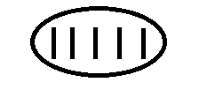

(iii) 16 = 3groups of fives, I ones = 31 fives



(iv) 28

28 = 1 group of five fives,3 ones =103five



(v) 37

37 = 1 group of five fives, 2 groups of fives 2 ones =121 five



**Activity**

1. Group the following numbers in base five

(a) 4 (b) 7 (c) 17 (d) 29 (e) 42

**PLACE VALUE OF BASES**

Examples

Find the place value of each digits in 123five.

**FF F 0**

1 2 3

Ones

Fives

Five fives

**Examples II**

Write the place value of each digit in 1101two

1 1 1 0 1 two

Ones

twos

Two twos

Two two twos

Two two two twos

**Example III**

What is the place value of each digit in 1211three

**Soln**

1 2 1 1three

Ones

Threes

Three threes

Three three threes

**Examples**

Write the place value of the underlined digits in 1 2 4 11

Five fives

Five fivefive fives

**Activity**

1. Find the place value of each digit.

(a) 4five (b) 132five (c) 1234 fives

2. Find the place value of each digits

(a) 10two (b) 101two (c) 101two

3. Find the place value of each digit

(a) 12 three (b) 202three (c) 1202three

4. Write the place value of the underlined digits.

(a) 1 2 4five (b) 1 0 1 two (c) 2 1 1 2 three

5. What is the place value of 4 in 2401five.

**WRITING BASES IN WORDS**

**Examples I**

1. 123five One two three base five.

**Example II**

4132five four one three two base five.

**Example III**

101 two One zero one base two.

2102three Two one zero two base three

**Activity**

Write the following numbers in words.

(a)43five (b) 123five

(c) 2142five (d) 1011two

(e)201three (f) 1010 two

(g)2102three (h)4232five

**EXPANDING BASES USING VALUES**

**Examples**

1. Expand 32five using values.

|  |  |
| --- | --- |
| 3 | 2 |
| 51 | 50 |

 (3 x 5 1) + (2 x 5 0)

(3 x 5) + (2 x 1)   
 15 + 2

2. Expand 124five using values.

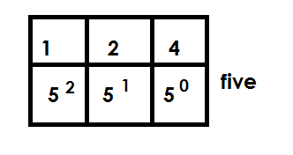1 2 4 five

(1 x 5 **2**) + (2 x 5 **1**) + (4 x 5 **0**)

(1 x 5 x 5) + (2 x 5) + (4 x 1)

25 t 10 + 4

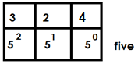3. Expand 324five using values.

324five

(3 x 52) + (2 x 5 1) + (4 x 5 0)

(3 x 5 x 5) + (2 x 5) + (4 x 1)

(3 x 25) + 10 + 4

75 + 10 + 4

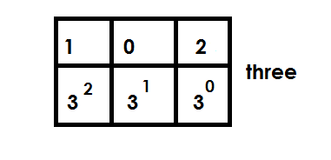4. Expand 102three using values

102three =

(1 x 32) + (0 x 31) + (2 x 30)

(1 x 3 x 3) + (0 x 3) + (2 x 1)

9 + 0 + 2

**Activity**

Expand the following using values.

(a) 43five (b) 123five (c) 432five

(d) 104five  (e) 101 three (f) 102 three

**EXPANDING BASES USING POWERS/ EXPONENTS/ INDICES**

**Examples**

Expand 403five using powers

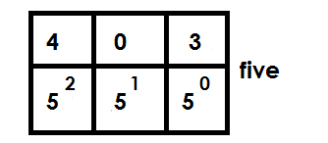**Soln**

403five =

(4 x 52) + (0 x 5 1) + (3 x 50)

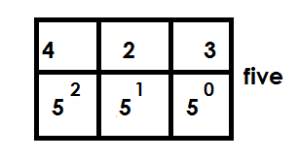Expand the following using powers.

(a) 423five =

(4 x 5 2) + (2 x 51) + (3 x 5 0)

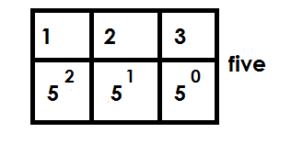(b) 123 five

123five =

(1 x 52) + ( 2 x 5 1) + ( 3 x 50)

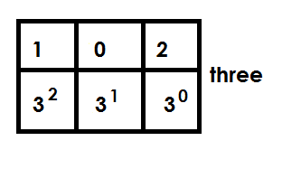(c) 102 three

102three =

( 1 x 3 2) + ( 0 x 3 1) + ( 2 x 30)

**Activity**

1. Expand the following using p

(a) 124five (b) 243 five (c) 423 five

(d) 104 five (e) 103 four

2. Expand 403 using exponents

**EXPANDING BASES USING PLACE VALUES**

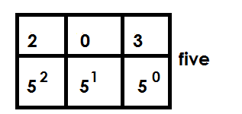**1.** Expand 203five using powers.

(2 x 5 2) + (0 x 51) + (3 x 50)

(2 x 5 x 5) + (0 x 5) + (3 x 1)

2. Expand 403 five using place values.

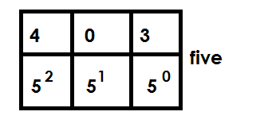

(4 x 5 2) + (0 x 51) + (3 x 50)

(4 x 5 x 5) + (0 x 5) + (3 x 1)

3. Expand 123five using place values

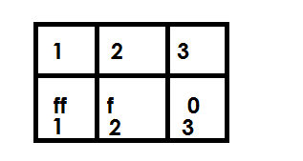

(1 x 5 x 5) + (2 x 5) + (3 x 1)

**Activity**

Expand the following using place values.

(a)23five  (b) 203five

(c) 101two (d) 432five

(d) 104five  (e) 121three

**CHANGING NON-DECIMAL BASES TO BASE TEN (DECIMAL BASE)**

**Examples.**

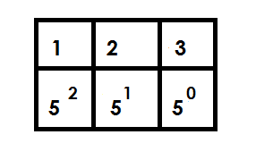1. Convert 123five to base ten.

123five =

(1 x 5 2) + (2 x 51) + (3 x 50)

(2 x 5 x 5) + (2 x 5) + (3 x1)

25 + 10 + 3

38ten

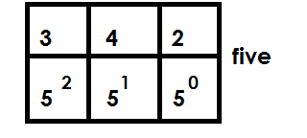2. Convert 342five to base ten

(3 x 52) + (4 x 51) + (2 x 50)

(3 x 5 x 5) + (4 x 5) + (2 x 1)

75 + 20 + 2

97 ten

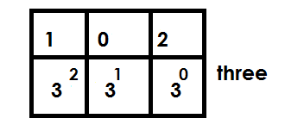3. Convert 102three to base ten

(1 x 32) + (0 x 31) + (2 x 30)

(1 x 3 x 3) + (0 x 3) + (2 x 1)

9 + 0 + 2

11 ten

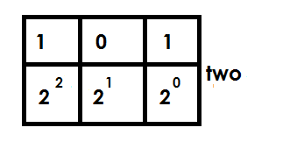4. Convert 101 two to base ten

(1 x 22) + (0 x 21) + (1 x 20)

(1 x 2 x 2) + (0 x 2) + (1 x 1)

4 + 0 + 1

5 ten

**Activity**

1. Convert 23five to base ten.

2. Convert 420five to decimal base.

3. Convert 123five to base ten.

4. Convert 403five to base ten.

5. Convert the following bases to base ten.

(a) 304five (b) 424five  (c) 102three (d) 202 three (e) 111two

**CHANGING FROM BASE TEN TO OTHER BASE**

**Note:**

Factorise using the required base.

**Examples.**

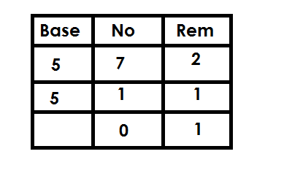1. Change 7ten to base five.

7 ten = 12 five

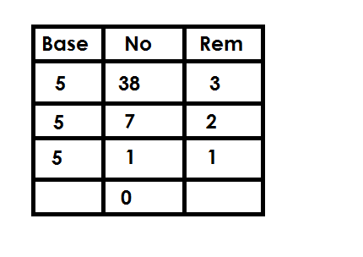2. Convert 38ten to base five

38 ten = 123five

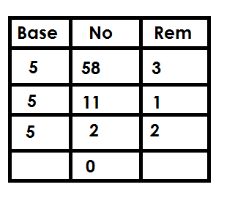3. Convert 58ten to base five

58ten = 213 five

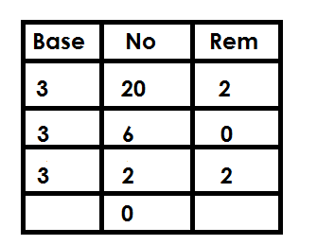4. Convert 20ten to base three

20 ten = 202 three

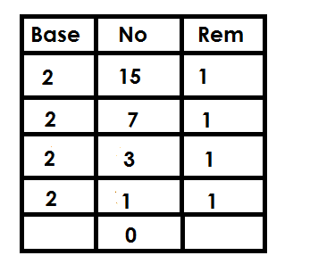5. Convert 15ten to base two.

15ten = 1111two

**Activity**

1. Convert 9ten to base five.

2. Convert the following to base five.

(a) 25ten (b) 30ten (c) 29ten

(d) 42 ten (e) 55ten

3. Convert 30ten to base three

4. Convert 20 ten to base two.

**ADDITION OF BASE NUMBERS**

**Example I**

Add: 1 2 3five

+ 1 1five

1 3 4five

**Example II**

Add: 1 4 2 five 6 ÷ 5 = 1 rem 1

+ 2 1 five

2 1 3 five

**Example III**

Add : 1 4 2 3 five 5 ÷ 5 = 1 rem 0

+ 2 1 2five 6 ÷ 5 = 1 rem 1

1 1 4 0 five

**Example IV**

Add: 1 0 2 three 4 ÷ 3 = 1 rem 1

+ 1 2 three

1 2 1 three

**Example V**

Add : 1 1 0 1 two 2 ÷ 2 = 1 rem 0

+ 1 1 1 two 2 ÷ 2 = 1 rem 0

1 1 0 0 two  3 ÷ 2 = 1 rem 1

**Example VI**

Add: 1 0 2 three 3 ÷ 3 = 1 rem 0

+ 1 1 1 three

2 1 0 three

**Activity**

1. Add: 1 2 3 five 2. Add: 2 4 3 five

+ 3 1 five + 2 4 five

3. Add: 4 0 3 five 4. Add: 4 4 0 five

+ 1 2five + 4 3 five

5. Add: 1 1 1 two 6. Add: 2 0 1 three

+ 1 1 1 two + 1 0 2 three

7. Add: 1 2 2 three

+ 2 1 1 three

**SUBTRACTION OF BASES**

**Note**: The one regrouped is worth the value of the base.

**Example I**

**3 5**

**Subtract**  4 0 2 five

- 1 1 five

3 4 1 five

**Example Il**

**1 4 5+**

Subtract: 2 0 1 five

- 4 2 five

1 0 4 five

**Example IIl**

**5 5+0 (5 +)**

Subtract 3 1 2 five

- 1 2 3 five

1 3 4 five

**Example IV**

**0 5+**

Subtract 1 2 4 five

- 4 3 five

3 1 five

**Example V**

**0 2**

Subtract: 1 1 0 two

- 1 0 1 two

0 0 1 two

**Example VI**

**0 0 2**

Subtract: 1 1 0 1 two

- 1 1 1 two

1 1 0 two

**Example VII**

**1 3**

Subtract: 2 0 2 three

-1 2 1 three

1 1 three

**Activity**

1. Subtract 1 2 3 five 2. Subtract 4 0 2 five

- 1 2 five - 1 2 five

3. Subtract 4 1 3 five 4. Subtract 3 2 4 five

- 3 1 4 five  - 1 4 2 five

4. Subtract: 3 2 4 five 5. Subtract 4 0 1 five

- 1 4 2 five -1 2 3 five

6. Subtract 2 0 1 three 7. Subtract 1 2 0 three

- 1 2 1 three - 1 0 1 three

8. Subtract 1 0 1 two

- 1 1 two

**MULTIPLICATION OF BASES**

**Example I**

1. Multiply: 2 five x 3

3 five 6 ÷ 5 = 1 rem 1

X 2 five

1 1 five

2. Multiply: 4 2 1 five x 2

4 2 1 five 2 x 1 = 2

X 2 8 ÷ 5 = 1 rem 3

1 3 4 2 five

3. Multiply: 40 five x 3

2 4 0 five 12 ÷ 5 = 2 rem 2

X 3

2 2 0 five

4. **Example IV**

1 2 three x 2 4 ÷ 3 = 1 rem 1

1 1 2 three 3 ÷ 3 = 1 rem 0

X 2 three

1 0 1 three

**Activity**

1. Multiply: 4five x 3

2. Work out 12five x 4

3. Work out 21five x 3

4. 121five x 3

5. 321five x 2

6. 113five x 3

7. Multiply: 21 three x 2

**FINITE SYSTEM**

Is a way of expressing numbers as remainders.

**Counting in finite system**

**Examples**

1. Express 11 in finite 5

**Soln**

11 = 2 r 1

5

11 = 1 (finite 5)

2. Write 17 in finite 5

**Soln**

17 ÷ 5 = 3 rem 2

17 = 2 (finite 5)

3. Change 9 to finite 7

**Soln**

9 ÷ 7 = 1 rem 2

9 = 2 (finite 7)

4. Express 23 in finite 8.

**Soln**

23 ÷ 8 = 2 rem 7

23 = 7 (finite 8)

5. Write 32 in finite 8

**Soln**

32 ÷ 4 = 4 rem o

32 = 0 (finite 8)

**Activity**

1. Express the following in finite 5

(a) 9

(b) 5

(c) 13

(d) 19

(e) 20

2. Change the following to finite 7

(a) 22

(b) 33

(c) 8

(d) 53

(e) 49

3. Write the following in finite 8.

(a) 14

(b) 16

(c) 26

(d) 38

(e) 47

**ADDITION IN FINITE USING ADAIL**

1. Add: 3 + 4 = (finite 5) using a dail.

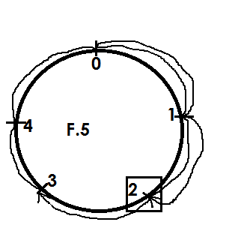



3 + 4 = 2 (finite 5)

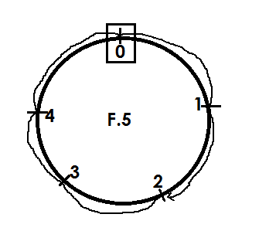2. Using a dail, add: 2 + 3 = (finite 5 )



2 + 3 = 0 (finite 5)

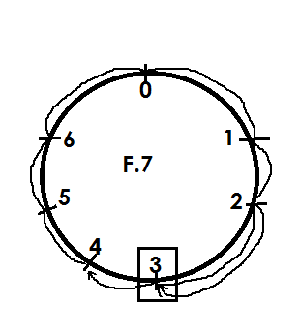3. Work out 4 + 6 = (finite 7)

Soln



4 + 6 = 3 (finite 7 )

4. Using a dail, work out: 3 + 4 = (finite 8)

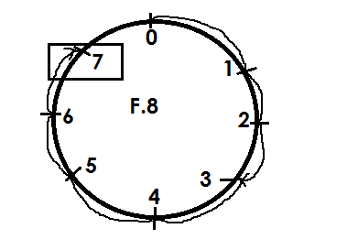



3 + 4 = 7 (finite 8)

**Activity**

Using a dail, add the following.

1. 2 + 1 = (finite 5)
2. 4 + 2 = (finite 5)
3. 5 + 4 = (finite 7)
4. 2 + 3 = (finite 7)
5. 3 + 5 = (finite 7)
6. 6 + 5 = (finite 7 )
7. 4 + 3 = (finite 8)
8. 5 + 3 = (finite 8)
9. 7 + 4 = (finite 8)

**ADDITION IN FINITE WITHOUT USING A DAIL**

**Note**:

When the sum obtained is less than the given finite, maintain the sum as the answer without dividing by the finite.

**Example I**

Add: 4 + 3 = (finite 5)

Soln

4 + 3 = (finite 5)

7 ÷ 5 = 1 rem 2

Therefore 4 + 3 = 2 ( finite 5)

**Example II**

Add : 2 + 4 = (finite 7)

2 + 4 = 6 ( finite 7)

**Example**

Work out: 2 + 1 + 6 = (mod 7)

2 + 1 + 6 = _______ (mod 7)

9 = 1 rem 2

7

2 + 1 + 6 = 2 ( mod 7)

**Activity**

1. **Add the following**

(a) 1 + 1 = (finite 5)

(b) 2 + 3 = (finite 5)

(c) 5 + 4 = ( finite 7)

(d) 3 + 4 = (finite 5)

(e) 6 + 6 = (finite 7)

(f) 4 + 2 = (finite 5)

(g) 2 + 3 + 4 = (finite 6)

(h) 6 + 5 + 1 = (finite 12)

(i) 4 + 3 + 5 = (finite 8)

**SUBTRACT INFINITE USING ADAIL**

**Example I**

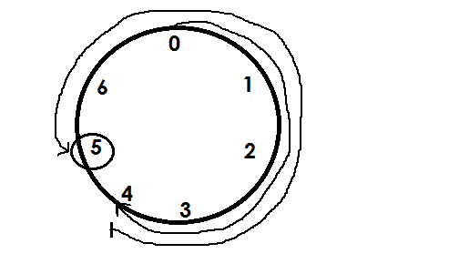Work out: 4 – 6 = (mod 7)



4 - 6 = 5 ( mod 7)

**Example 2**

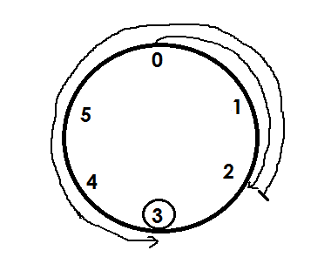Subtract: 2 – 4 = (finite 5)



2 - 4 = 3 finite 5.

**Activity**

1. Workout the following using a dail.

(a) 2 - 4 = (mod 6)

(b) 4 - 7 = (finite 12)

(c) 3 – 5 = (mod 7)

(d) 5 – 8 = (mod 9)

(e) 1 - 4 = (mod 4)

(f) 2 – 3 = (mod 5)

(g) 1 - 4 = (finite 6)

(h) 5 – 7 = (finite 8)

**PATTERNS AND SEQUENCES**

**Review of P.4 Work on G.C.F and L.C.M from listed factors and multiples**

**Mk MTC Bk. 5 pg 80 – 82**

**TYPES OF NUMBERS.**

1) Whole numbers 0, 1, 2, 3, 4, 5, …

2) Counting numbers/ Natural numbers 1, 2, 3, 4, 5,.

3) Odd numbers: These are numbers that give a remainder when divided by 2

{1, 3, 5, 7, …

4) Even numbers: These are ones that are exactly disable by two

 {0, 2, 4, 6, 8, 10, …}

5) Prime numbers: These are numbers with only two factors.

 {2, 3, 5, 7, 11, 13, …}

6) Composite numbers: These are numbers with more than 2 factors

{4, 6, 8, 9, 10, 12, …}

7) Square numbers: These are numbers got by multiplying a number by its self.

 {1, 4, 9, 16, 25, …}

8) Cube numbers: These are got by multiplying the same number three times.

{1, 8, 27, 64, …)Triangular numbers: These are got by adding consecutive counting numbers.

{1, 3, 6, 10, 15, 21…}

+2 +3 +4 +5 +6

**REFERENCE: Understanding MTC bk 6 pg 81 – 84**

**Mk Bk 5 Pg 80 – 89**

**PRIME FACTORIZATION OF NUMBERS**

Prime factorizing means dividing a number by its prime factors.

We use prime factors when prime factorizing e.g. = {2, 3, 5, 7, 11, 13 …}

**Example I**

Prime factorize 18.

We can either use a ladder or a factor tree. i.e.

2 18

3 9

3 3

1

We can represent the prime factors as follows.

Set notation / subscript form

18 = {21, 31, 32}

**Multiplication form**

18 = 2 x 3 x 3

power form (expanded form)

18 = 21 x 32

**Example II**

Prime factorize 100.

* Take note of factors of 100 that are prime numbers.

100 Subscript form ÷

2 50 100 = {21, 22, 51, 52}

2 25 Multiplication form

5 5 100 = 2 x 2 x 5 x 5

5 1 Power form

100 = 22 x 52

**Ref: MK MTC BK. 5 pg 84 – 85, Fountain MTC BK. 5 pg 106 – 108**

**Understanding MTC Bk. 5 Pg. 79 – 81**

**FINDING L.C.M BY PRIME FACTORIZING**

**Example**

Find the L.C.M of 4 and 12 by prime factorization.

2 4 12

2 2 6

3 1 3

1 1

L.C.M = 2 x 2 x 3

= 4 x 3

= **12**

**Example II**

Find the L.C.M of 12 and 20.

2 12 20

2 6 10 L.C.M = 2 x 2 x 3 x 5

3 3 5 = 4 x 15

5 1 5 **= 60**

1 1

**REFERENCE: MK MTC Bk 5 pg 86.**

**FINDING G.C.F BY PRIME FACTORIZING**

**Example:**

Find the G.C.F of 6 and 8

2 6 8

3 4

**G.C.F = 2**

**Example II**

Find the G.C.F of 24 and 36.

2 24 36

2 12 18

3 6 9

2 3

G.C.F = 2 x 2 x 3

Reference: = 4 x 3 = **12**

NEW MK. BK 5 PAGE 87

**REPRESENTING PRIME FACTORS ON VENN DIAGRAMS**

**Example I**

Represent the prime factors of 12 and 18 on a Venn diagram.

1. 12 2 18

2 6 3 9

3 3 3 3

1 1

F12 = { 21, 22, 31 }

F18 = { 21, 31, 32 }

F12  F18

22 21

31 32

a) Find the G>C>F of 12 and 18.

G.C.F product of the intersection

F12∩F18 = {21, 31 }

 **G.C.F = 2 x 3**

**6**

L.C.M = product of the union.

F12F18 = {21, 22, 31 , 32}

= 2 x 2 x 3 x 3

= 4 x 9

= **36**

**Example 2**

Below is a Venn diagram showing factors.

F70  F30

71 21

51 31

a) Find the G.C.f of 70 and 30.

G.C.F = product of the intersection

F70∩F30 = {21, 51 }

G.C.F = 2 x 5

= **10**

b) Find the L.C.M of 20 and 70.

L.C.M =product of the union

L.C.m = 21 x 31 x51 x71

= 6 x 35

**L.C.M** = **210.**

**Activity: Fountain MTC Bk. 5 Pg 118 - 119**

**MK MTC BK. 6 pg. 86**

**FINDING THE UNKNOWN NUMBER GIVEN PRIME FACTORS ON A VENN DIAGRAM**

Fx  Fy

23 21

22 51

31

a) Find the value of x.

Fx = {21, x 22 , x 31}

x = 4 x 6

x = **24**

b) Find the value of y.

Fy = {21, 22 ,31, 51}

y = 21 x 22 x31 x 51

y = 2 x 2 x 3 x 5

y = 4 x 15

y = **60**

**REFERENCE: MK BK 6 Pg 88 – 89**

**SQUARE ROOTS OF NUMBERS**

Review of square numbers.

i.e. {1, 4, 9, 16, 25, 36, 49, 64, 81, …}

A square number is got by multiplying a number by itself.

A square root is a number that is multiplied by its self to give a square number.

The symbol for square root is √

**Example**

Find the square root of 36.

2 36  = 

2 18  = 2 x 3

3 9 = **6**

3 3

1

**Example:**

Find the square root of 100.

2 100  = 

2 50 = 2 x 5

5 25 = **10**

5 5

1

**Ref: MK MTC BK. 5 pg. 89, MK MTC BK. 6 pg. 95**